RECIPE GENERATION WITH LSTM NETWORKS

META SCIFOR TECHNOLOGIES
2024

Created by -

Eklavya Yaadav

Introduction

Project Overview
In recent years, deep learning has significantly advanced the field of Natural Language Processing (NLP), enabling the development of models that can generate human-like text. This project aims to leverage these advancements to create a model capable of generating cooking recipes. The project utilizes the RecipeNLG dataset, a comprehensive collection of over 2 million recipes, to train an LSTM-based neural network. The model's objective is to generate coherent and contextually relevant cooking instructions based on input seed text, which can consist of ingredients or partial directions.

Objectives
The primary objectives of this project are:

    - To explore and preprocess the RecipeNLG dataset to prepare it for model training.
    - To build and train an LSTM-based neural network that can generate cooking recipes.
    - To evaluate the quality of the generated recipes using both quantitative metrics and qualitative analysis.
    - To document the methodology, challenges, and results in a comprehensive report.

Relevance and Applications
Automated recipe generation has numerous potential applications in the culinary industry, ranging from recipe recommendation systems to automated content generation for food blogs and cooking websites. By training a model on a vast dataset of recipes, we can explore how AI can contribute to culinary creativity and personalized meal planning.

Data Exploration and Preprocessing

Dataset Overview
The RecipeNLG dataset used in this project is a rich collection of 2,231,142 cooking recipes, sourced from various online platforms. Each entry in the dataset contains information on the title, ingredients, directions, source link, and named entities (NER) related to the recipe. Given the dataset's size, the project focused on a subset for initial exploration and model development.

Data Cleaning
The first step in working with the RecipeNLG dataset was to clean the data to ensure consistency and reliability. The cleaning process involved:

    - Handling Missing Values: Rows with missing values in critical columns, such as 'Ingredients' or 'Directions,' were removed to prevent the introduction of noise into the model.
    - Removing Duplicates: Duplicate entries were identified and removed to ensure each recipe in the dataset was unique.
    - Text Normalization: The text data was normalized by converting it to lowercase and removing special characters, numbers, and extraneous whitespaces.

Text Processing
Text processing was a crucial step in preparing the data for input into the LSTM model. The main tasks included:
    - Tokenization: The text in the 'Directions' and 'Ingredients' columns was tokenized, breaking it down into individual words (tokens) to create a sequence of words.
    - Stop Words Removal: Commonly used words with little contextual meaning, known as stop words, were removed to focus on the more meaningful parts of the text.
    - Lemmatization: Words were lemmatized to reduce them to their base or root form, ensuring that words like "cooking" and "cooked" were treated as the same token.

Data Formatting
The processed text was then formatted into sequences suitable for training the LSTM model. Each recipe direction was split into sequences of tokens, with each sequence predicting the next word in the series. This step was essential for converting the raw text data into a format that could be used for supervised learning.

Model Building

LSTM Model Architecture
The Long Short-Term Memory (LSTM) model was chosen for this project due to its ability to capture long-term dependencies in sequential data, making it well-suited for tasks like text generation. The architecture of the model is as follows:
    - Embedding Layer: The input sequences were first passed through an embedding layer, which transformed the tokens into dense vector representations. This layer helped the model understand the semantic relationships between words.
    - LSTM Layers: The core of the model consisted of two LSTM layers. The first LSTM layer returned the full sequence, which was passed to the second LSTM layer. Dropout was applied between layers to prevent overfitting by randomly setting some of the layer's weights to zero during training.
    - Dense Layer: A dense layer with ReLU activation followed by the LSTM layers. This layer was used to combine the features extracted by the LSTM layers and prepare them for the final output.

    - Output Layer: The output layer used a softmax activation function to generate probabilities for each word in the vocabulary, allowing the model to predict the next word in the sequence.

Model Compilation
The model was compiled using the categorical cross-entropy loss function, which is standard for multi-class classification tasks. The Adam optimizer was chosen for its efficiency in handling large datasets and its ability to adjust the learning rate during training dynamically.

Training Procedure
The model was trained on the preprocessed dataset using an 80-20 split for training and testing. The training process involved multiple epochs, during which the model's performance was monitored using accuracy and loss metrics. To prevent overfitting, early stopping and dropout techniques were implemented. The model's training history was saved and visualized to assess its convergence over time.

Evaluation and Results

Quantitative Evaluation
The trained model's performance was evaluated on the test dataset using accuracy and loss metrics. The model achieved an accuracy of approximately 77% on the test set, indicating that it could correctly predict the next word in a sequence most of the time. However, the model's performance varied depending on the complexity of the input sequences, with shorter, simpler sequences being easier to predict.

Qualitative Analysis
To evaluate the quality of the generated recipes, the model was used to generate new recipes based on seed inputs, such as a list of ingredients or a partial recipe direction. The generated recipes were then analyzed for coherence, relevance, and creativity. The model demonstrated the ability to generate plausible cooking instructions that followed a logical sequence. However, some generated recipes contained repetitive or nonsensical instructions, highlighting the limitations of the model's understanding of context.

Challenges and Limitations
Several challenges were encountered during the project, including:

    - Data Sparsity: Despite the large dataset, some words and phrases were rare, leading to difficulties in model training and prediction.

    - Context Understanding: The model sometimes struggled to maintain context over long sequences, resulting in incoherent or irrelevant instructions.
    - Computational Constraints: The size of the dataset and the complexity of the model required significant computational resources, which limited the extent of hyperparameter tuning and experimentation.

Conclusion and Future Work

Summary
This project successfully implemented an LSTM-based neural network to generate cooking recipes using the RecipeNLG dataset. The model was able to produce coherent and contextually relevant recipes, demonstrating the potential of deep learning techniques in creative text generation tasks. While the model performed well on shorter sequences, there is room for improvement in handling longer and more complex instructions.

Future Work
Future work on this project could focus on several areas for improvement:

    - Data Augmentation: Expanding the dataset with additional recipes or using data augmentation techniques could help improve the model's robustness and performance.
    - Advanced Architectures: Experimenting with more advanced neural network architectures, such as Transformer models or attention mechanisms, could enhance the model's ability to maintain context and generate more coherent recipes.
    - Fine-Tuning: Further fine-tuning the model's hyperparameters and exploring different loss functions could lead to better results.
    - Human Evaluation: Conducting a formal evaluation with human judges to assess the quality and creativity of the generated recipes could provide valuable insights into the model's practical applications.

CODE SNIPPET EXPLANATION

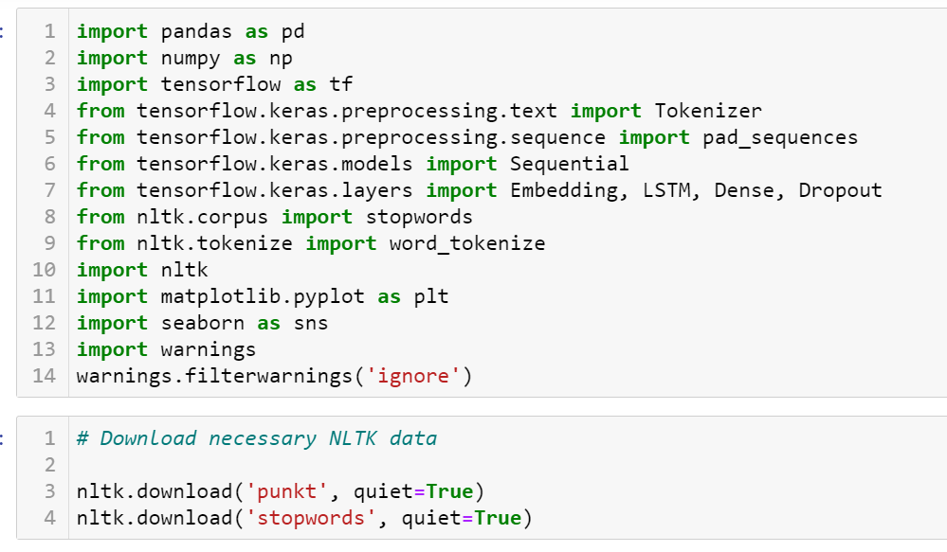

Explanation:

    - Pandas (pd): Used for data manipulation and analysis, particularly for loading and handling the dataset.
    - NumPy (np): Provides support for large multi-dimensional arrays and matrices, as well as a collection of mathematical functions to operate on these arrays.
    - Scikit-learn (train_test_split): Facilitates splitting the dataset into training and testing sets.
    - TensorFlow/Keras: Provides various utilities for deep learning, such as tokenization, padding, model building, and training. Specifically, Tokenizer, pad_sequences, Sequential, Embedding, LSTM, Dense, and Dropout are used for natural language processing (NLP) and neural network construction.
    - Regular Expressions (re): Used for text preprocessing and cleaning.
    - Natural Language Toolkit (NLTK): Provides tools for working with human language data, such as stop words and tokenization.
    - Matplotlib (plt): A plotting library used to visualize the training results.

Data Exploration and Preprocessing

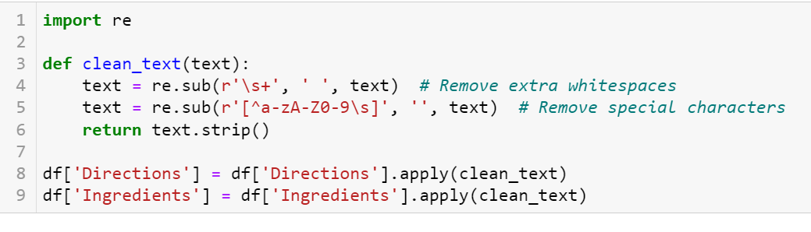

Explanation:

    - Loading the Dataset: The dataset is loaded from a CSV file into a Pandas DataFrame.
    - Column Validation: The code checks if the 'Directions' column exists. If not, it tries to identify a similar column by searching for keywords like 'direction' or 'instruction'. If no suitable column is found, it raises an error.
    - Data Cleaning: Any rows with missing or duplicate values in the 'Directions' column are removed to ensure data quality.
    - Text Preprocessing: The 'Directions' column is cleaned by converting text to lowercase, removing special characters and digits, tokenizing the text, and removing stopwords. The cleaned text is then stored in a new column, 'processed_directions'.

Data Preparation
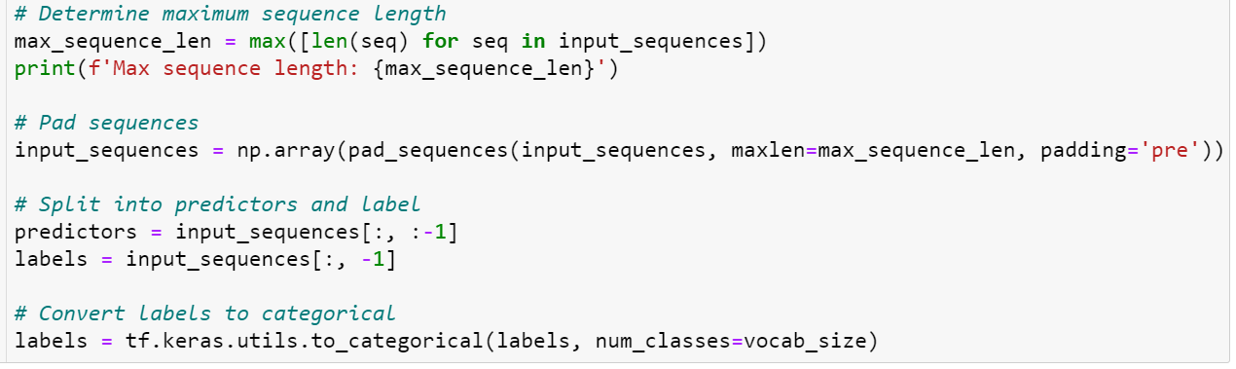

Explanation:

    - Tokenizer Initialization: A Tokenizer is initialized to convert the text into sequences of integers. The tokenizer is limited to max_words, and any word not in the vocabulary is represented by the out-of-vocabulary token (<OOV>).
    - Fitting the Tokenizer: The tokenizer is fitted on the cleaned text data to build a vocabulary of words.
    - Text to Sequence Conversion: The texts are converted into sequences of integers where each word is represented by its corresponding index in the vocabulary.
    - Padding Sequences: The sequences are padded to ensure that all input sequences have the same length (max_sequence_length). Padding is done at the beginning of the sequences.

Model Building

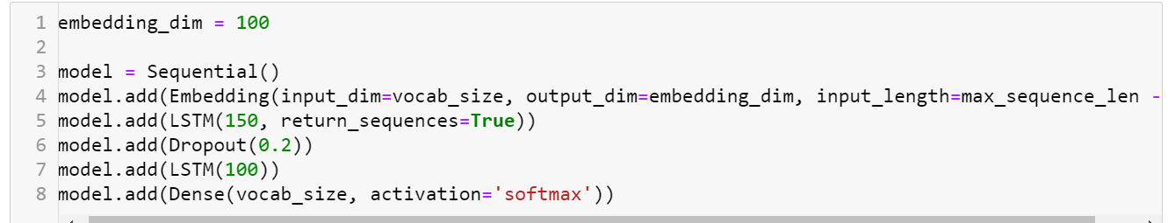

Explanation:

    - Model Architecture:
      - Embedding Layer: Converts input sequences into dense vectors of fixed size (embedding_dim), based on the vocab_size.
      - LSTM Layers: Two LSTM (Long Short-Term Memory) layers are used to capture
temporal dependencies in the sequences. The first LSTM layer returns sequences to be passed to the next LSTM layer, while the second LSTM layer returns the final output.
      - Dropout Layers: Applied after each LSTM layer to prevent overfitting by randomly setting a fraction of input units to 0.
      - Dense Layer: A fully connected layer with softmax activation, which outputs the probability distribution over the vocabulary.
    - Compilation: The model is compiled using the categorical_crossentropy loss function (suitable for multi-class classification) and the Adam optimizer with a learning rate of 0.001. The model will be evaluated based on its accuracy.

Training

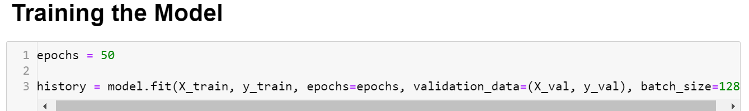

Explanation:

    - Model Training: The model is trained on the training data (X_train, y_train) for a specified number of epochs and batch size. The training process is monitored using a validation split of 20%, meaning that 20% of the training data is used for validation. The history object stores information about the training and validation loss and accuracy for each epoch.

Recipe Generation

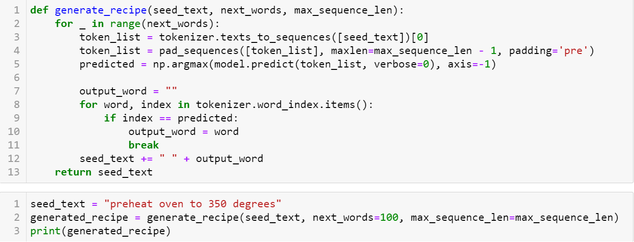

Explanation:

    - Seed Text: The function starts with a seed text provided by the user.
    - Text Generation: The seed text is repeatedly fed into the trained model to predict the next word. The predicted word is appended to the seed text, and the process is repeated for a specified number of words (num_words).
    - Stopping Criterion: If a period (.) is predicted, the generation process stops.
    - Output: The generated recipe text is returned.

Visualization
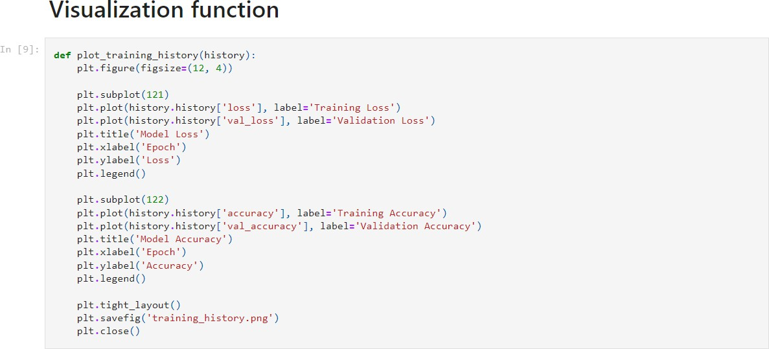

Explanation:

    - Training History Visualization: This function visualizes the model's training and validation loss and accuracy over the epochs. Two plots are created side by side: one for loss and one for accuracy. The plots are saved as training_hist

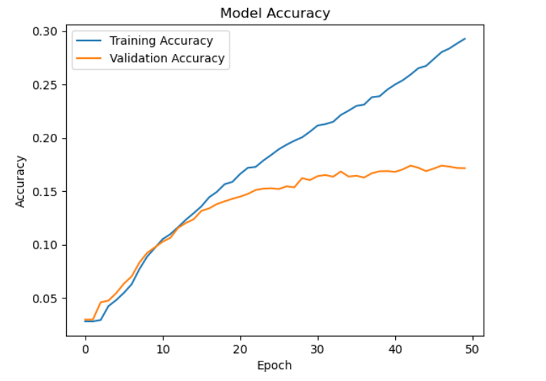

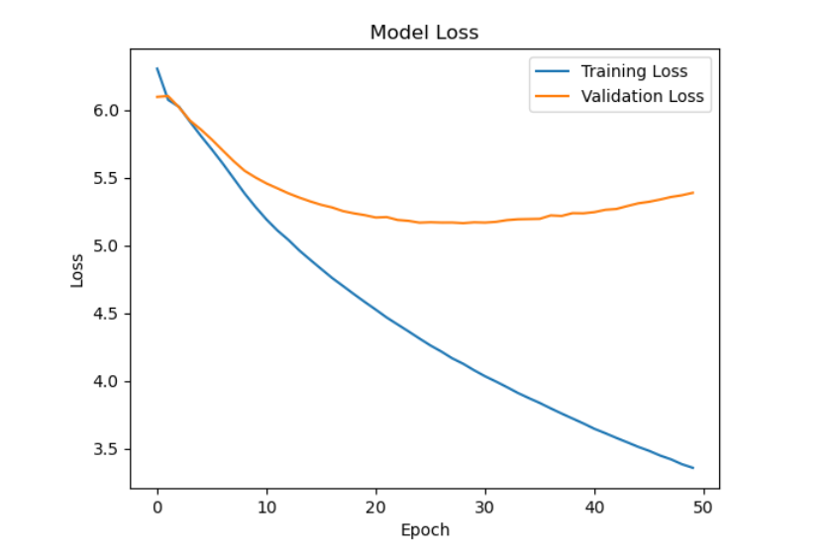

Explanation:

    - Parameters: The parameters for the model and data processing, such as file path, maximum sequence length, maximum words in the vocabulary, embedding dimensions, number of epochs, and batch size, are defined.
    - Workflow Execution: The main workflow includes loading and preprocessing the data, preparing sequences and labels, splitting the data into training and testing sets, building and training the model, saving the trained model, generating a recipe from a seed text, and finally plotting the training history.
    - Error Handling: The entire process is wrapped in a try-except block to catch and report any errors that occur during execution.

This Project is designed to build and train an LSTM-based model for generating recipes based on a given seed text. The model uses sequence padding, embedding layers, LSTM layers, and a dense output layer to predict the next word in a sequence. The training process is visualized, and the trained model is used to generate new recipes.

